Pathways to Write- Overview

Academic Year | Autumn 1 | Autumn 2 | Spring 1 | Spring 2 | Summer 1 | Summer 2
Year 1 | Core text: Lost and Found By Oliver Jeffers  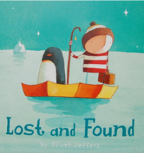  Construct own sentences  Write missing labels  Write about your own animal  Write factual sentences  Write speech bubbles  To write an adventure story based on the structure of ‘Lost and Found’ with a new animal | Core text: Katie in London By James Mayhew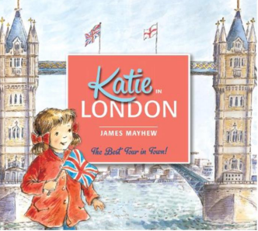  Write a postcard  Write sentences about London  Write about favourite sights  To write a non-chronological report about London using information gathered from the texts. | 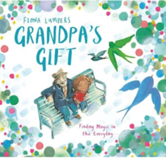  Core text: Grandpas gift By Fiona Lumbers  Write about a special object  Write statements and questions  Write a description  Write a note  Write a recount  Write a statement  Write a letter  write a story about a character who finds magic in everyday things based on the structure of the text. Change the main character and the setting | Core text: Beegu By Alexis Deacon  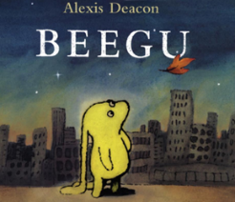  Write a message  Write questions  Write captions  Create a poster  Write a postcard  Write a message  To write their own version of the story with a new lost creature | Core text: Toys in Space by Mini Grey  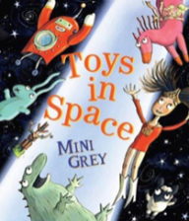  Write a description  Write in the third person about a toy  Write speech bubbles  Write a description  Write a letter  Write an invite  Write a diary  To write a fantasy story about some toys who are taken onto a spaceship. They will be changing some of the characters and the settings in the story | 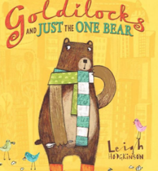  Core text: Goldilocks and just the one bear By Leigh Hodgkinson  To write a new version of the story with a new character or new setting  Write a story  Write a setting description  Write labels  Write speech bubbles  Write a diary
Year 2 | Core text: Look Up! By Nathan Bryon – Celebrating Black lives  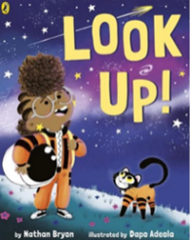  Write a setting description  Write a set of instructions  Write a menu  Write a diary  To write a diary entry about a space flight. | 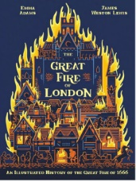  Core text: The great fire of London By Emma Adams  Write a description  Write a set of instructions  Write a pyramid poem  Write a diary  Write a fact file  To write a fact sheet about London and the events of the fire | Core text: Dragon Machine By Helen Ward  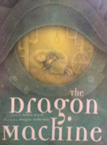  Create a poster  Write a character description  Write a diary  Create a leaflet  To write an adventure story based upon the model text using own ideas for a change of character and machine | Core text: My name is not refugee By Kate Milner  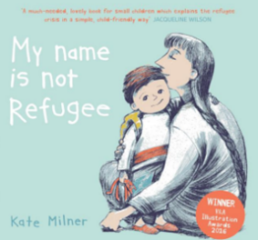  Create a poster  Write a letter  Write a character description  Write a poem  Write a message  To write a recount of events from the text from the character’s point of view | Core text: The last Wolf By Mini Grey  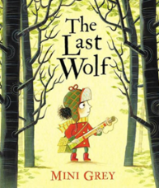  Write a speech  Write a guide  Write a list of rules  Write a setting description  Write a character description  Write directions  Write instructions  To write a letter in role persuading characters to save the trees | Core text: Grandads secret Giant By David Litchfield  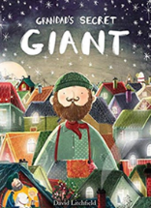  Write a leaflet  Write a character description  Write a diary entry  Write a letter  Write a setting description  To write own version of the story with a focus on morals and acceptance of others
Year 3 | Coming to England By Floella Benjamin  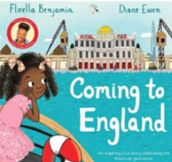  Write a description  Write a biographical description  Write a recount  Write a diary entry  Write a leaflet  Write a fact file  To write letters from Floella to her Grandmother telling her about settling into life in the UK | Winter’s Child by Graham Baker -Smith  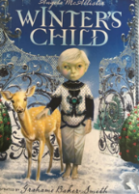  Write a list poem  Write a story based on predictions  Write a diary entry  Write a letter  Write a scene description  To write a fantasy story based on a fable | 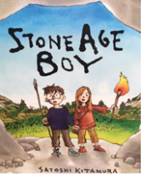  Stone Age Boy by Satoshi Kitamura  Write a story  Write a setting description  Write a report  Write the story from the point of view of the boy | 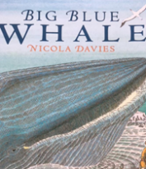  Big blue Whale by Nicola Davies  Write a recount  Write a letter or email  Write a poem  Write an informative article about whales persuading for the protection of the blue whale | Journey by Aaron Becker  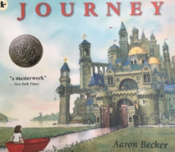  Write a letter  Write a diary  Write a note  Write a description  Write an adventure story based on ‘Journey’ using the language of Berlie Doherty | 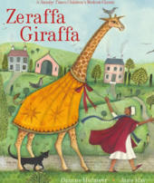  Zeraffa Giraffa by Dianne Hofmeyr  Write letters from different perspectives  Write eye witness accounts  Plan and write a persuasive guide for visiting Zeraffa at the Jardin des Plantes in Paris
Year 4 | 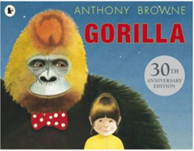  Core text: Gorilla by Anthony Browne  Write a short Narrative  Create a fact file  Write a diary entry  Write a speech  Write a third person description  To write a narrative based on the story of ‘Gorilla’ | 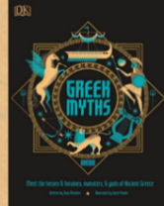  Core text: Greek myths by Jean Menzies  Write a story  Write a description  Write a short section of a story  Write a set of instructions  To make a mini-book of their own Odyssey adventure | Core text: Escape from Pompeii by Christina Balit  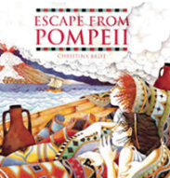  Write a story  Write a diary  Write a speech  Write an explanatory letter  Write the story from the point of view of one of the children | Core text: Amazing islands by Sabrina Weiss  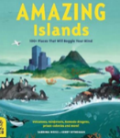  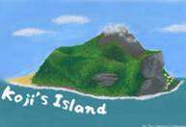  Write a setting description  Write a letter  Create a Travel Poster  To write their own version of ‘Koji’s Island’ in the first person from the point of view of the boy in the story. | Core text: Where the forest meets the sea by Jeannie Baker  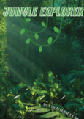  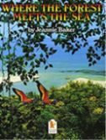  Write a description  Write an information leaflet  To make a zoo information board for a rainforest exhibit | Core text: Blue John by Berlie Doherty  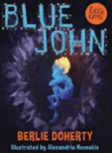  Write a letter  Write an explanation  Write a descriptive paragraph  Write a letter in role as an expert containing an explanation about cave formation
Year 5 | Core text: Race to the frozen North/ Young, gifted and black by Jamia Wilson  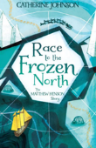  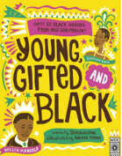  Write an in role short diary entry  Write a character profile  Write a recount  Compose an email  Write a letter  Write a setting description  Write a recount of an event  To write a series of diary entries about significant events in Matthew Henson’s life. | Core text: The Lost Happy Endings by Carol Ann Duffy  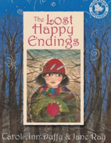  Write a 100 word story in the past tense  Write a poem containing similes and personification  Write a letter  To write a traditional tale focusing on describing settings, characters and an alternative ending | Core text: Arthur and the golden rope by Joe Todd-Stanton  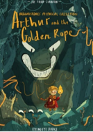  Write a character profile  Write e poem about a magical object  Write a recount  To write a myth: to create characters (heroes, villains and monsters) and settings | Core text: The Darkest Dark by Chris Hadfield  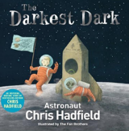  Write a recount  To write a formal biography | Core text: Brilliant Deep by Kate Messner  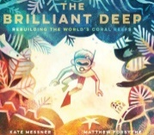  Write a fact file  Write a pledge  Write and information text  Write an information leaflet  To write an information leaflet to persuade children to consider the effects of climate change on coral reefs. | 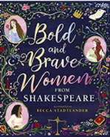  Core text: Bold and brave women from Shakespeare by Shakespeare Birthplace Trust  Write a description  Write a play script  Write a diary  Write a speech  To write and perform a soliloquy in role as one of Shakespeare’s bold and brave characters.
Year 6 | 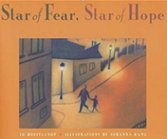  Core text: Star of fear, Star of hope by Hoestlandt  Write narrative of a scene  Write a description of a scene  Write a diary entry in role  Write a newspaper report  Write a letter  To write a story with a flashback from another character’s point of view | Core text: The place for me; stories about the Windrush generation by K.N. Chimbiri  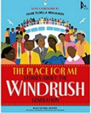  Write and information text  Write a persuasive letter  Create a persuasive poster  Write a Diary in role  Write persuasive recount paragraphs  To write an information leaflet about a period in Black history | Core text: Selfish giant by Oscar Wilde and Ritva Voutila  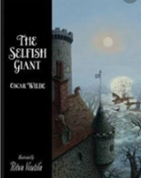  Write a narrative based on clues from the text  Write a formal poem  Write a first-person letter  Write a formal monologue  Write a newspaper report  To write a version of the Selfish Giant narrative - choosing either a retelling in 1st or 3rd person or from a character’s point of view  Plan, draft and write an explanation text - A guide for humans in a giant world | Core text: The island by Jason Chin  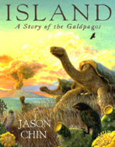  Write short newspaper report paragraphs  Write a field log in the role of a scientist  To write a journalistic report (hybrid) about Charles Darwin’s discoveries  To write a discussion text | Core text: Manfish by Jennifer Berne  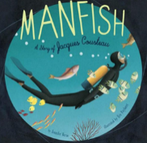  Pupils write a section for a biography  Write a persuasive paragraph  Write a diary or journal entry  To write a multi-modal biography of Jacques Cousteau in the style of the ‘Great Adventurers’ text  Pupils plan and write an imaginary adventure story | Core text: Poetry for kids; William Shapespeare by Marguerite Tassi  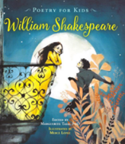  Write a biography  Write an invitation  Write a poem based on personal experience  Write a short speech  To write a sonnet as a goodbye to a teacher, a friend or the primary school itself.

