**

# Reading

**VIPERS Progression**

# KS1 Reading Domains

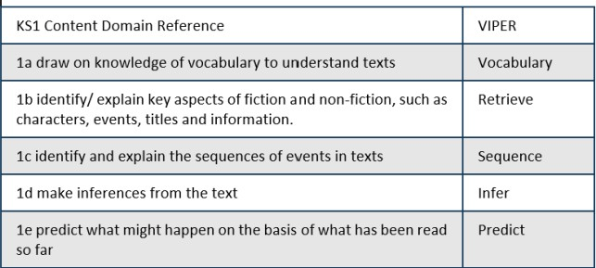

**KS2 Reading Domains**

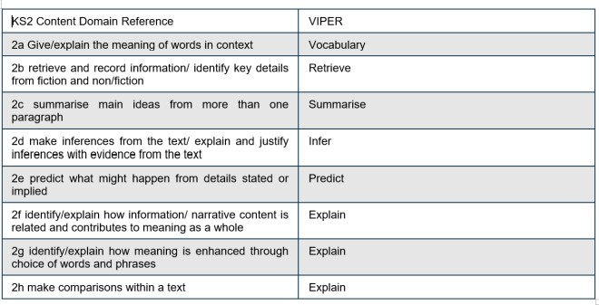

*VIPERS based on resources from Literacy Shed*

|  |  |  |  |  |
| --- | --- | --- | --- | --- |
| Vocabulary | | | | |
| **Year 2** | **Year 3** | **Year 4** | **Year 5** | **Year 6** |
| Understand and recognize simple recurring literary language in stories and  poetry | Understand what he/she reads independently by checking that the text makes sense to | Maintain positive attitudes to reading and understanding of what he/she reads by using dictionaries | Understand what he/she reads by checking that the book makes sense to him/her, discussing | Understand what he/she reads by identifying how language, structure and presentation |
|  | him/her, discussing | to check the | his/her | contribute to |
|  | his/her | meaning of words | understanding and | meaning |
|  | understanding of | that he/she has read | exploring the |  |
|  | words |  | meaning of words in |  |
|  |  |  | context |  |
| Discuss and clarifying | Understand what | Understand what | Discuss and evaluate | Discuss and evaluate |
| the meanings of | he/she reads | he/she reads | how authors use | how authors use |
| words, linking new | independently by | independently by | language, including | language, including |
| meanings to known | identifying how | checking that the | figurative language, | figurative language, |
| vocabulary | language, structure, | text makes sense to | considering the | considering the |
|  | and presentation | him/her, discussing | impact on the reader | impact on the reader |
|  | contribute to | his/her |  |  |
|  | meaning to include | understanding and |  |  |
|  | paragraphs, | explaining the |  |  |
|  | headings, sub- | meaning of words in |  |  |
|  | headings, inverted | context |  |  |
|  | commas to |  |  |  |
|  | punctuate speech |  |  |  |
|  |  | Maintain positive attitudes to reading and understanding of what he/she reads by discussing words and phrases that capture the reader's interest and  imagination |  |  |
|  |  | Understand what he/she reads independently by identifying how language, structure, and presentation contribute to meaning, to include: paragraphs, use of pronouns for cohesion, inverted commas for speech, apostrophes to mark  possession, fronted adverbials |  |  |

# Example Vocabulary questions

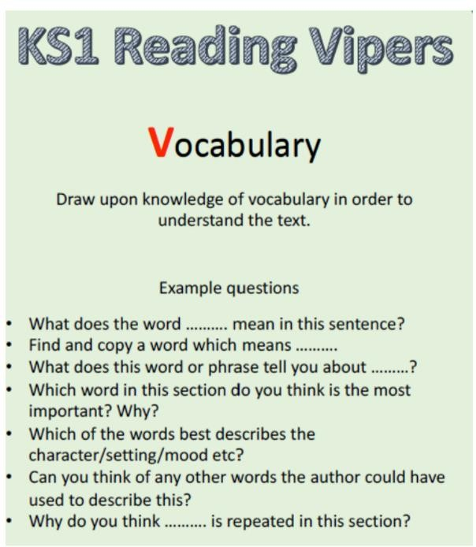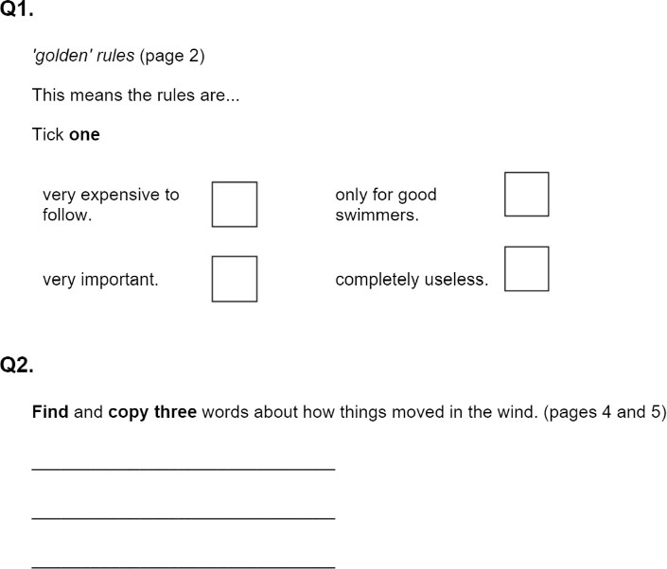

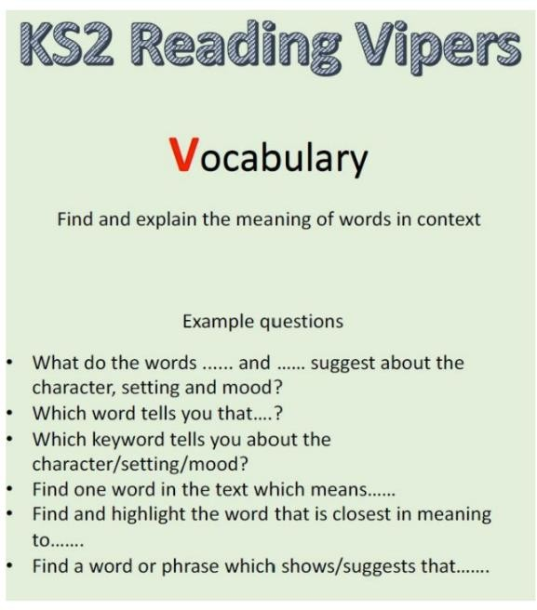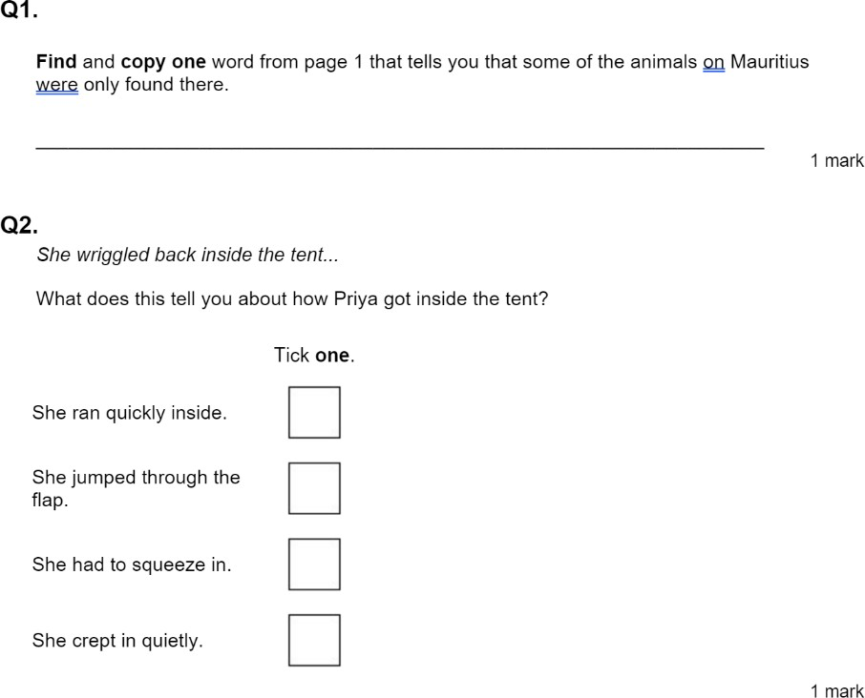

|  |  |  |  |  |
| --- | --- | --- | --- | --- |
| Inference | | | | |
| **Year 2** | **Year 3** | **Year 4** | **Year 5** | **Year 6** |
| Make inferences on | Understand what | Understand what | Understand what | Draw inferences |
| the basis of what is | he/she reads | he/she reads | he/she reads by | such as inferring |
| being said and done | independently by | independently by | drawing inferences | characters’ feelings, |
|  | drawing inferences | drawing inferences | such as inferring | thoughts and |
|  | such as inferring | such as inferring | characters' feelings, | motives from their |
|  | characters' feelings, | characters' feelings, | thoughts and | actions, and |
|  | thoughts and | thoughts and | motives from their | justifying inferences |
|  | motives from their | motives from their | actions, and | with evidence |
|  | actions, and | actions, and | justifying inferences |  |
|  | justifying inferences | justifying inferences | with evidence |  |
|  | with evidence | with evidence clearly |  |  |
|  |  | taken from the text |  |  |

Example Inference Questions

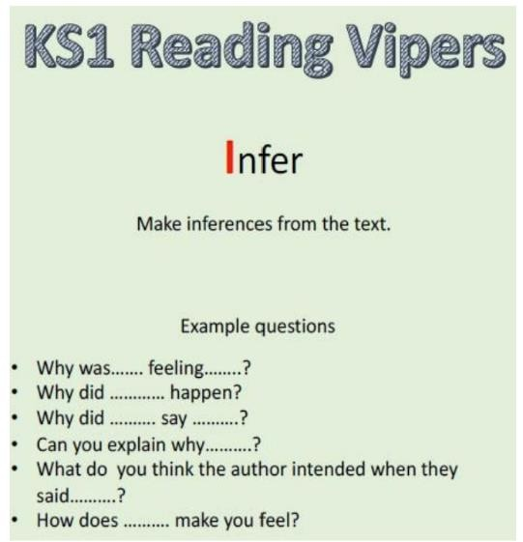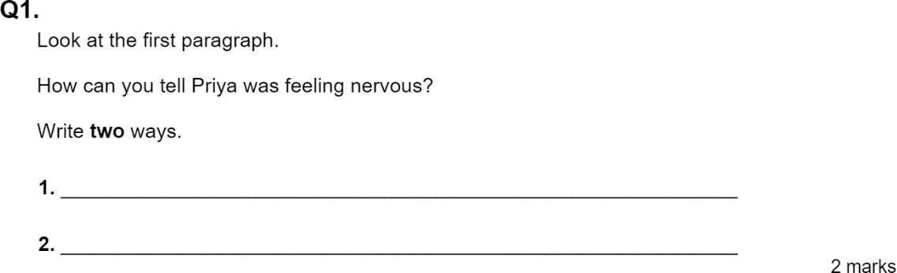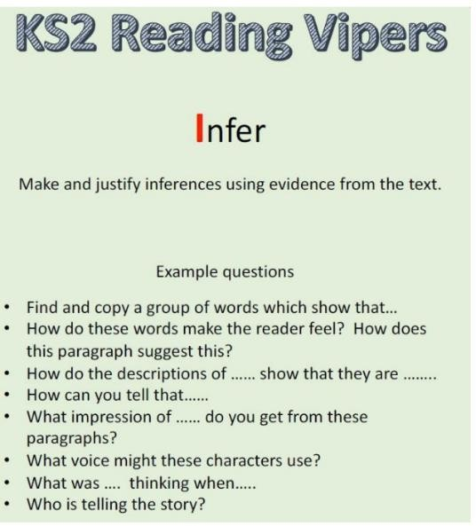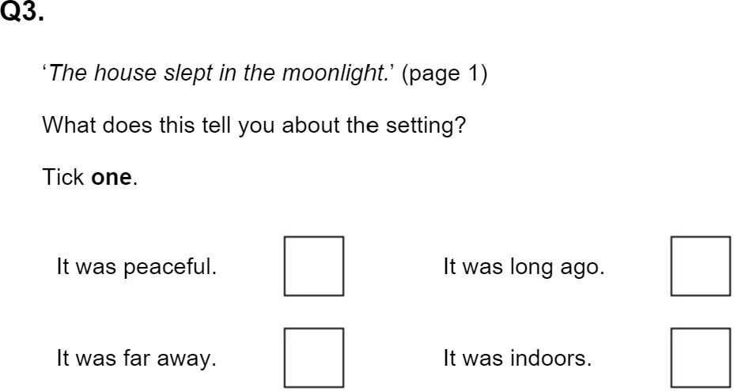

|  |  |  |  |  |
| --- | --- | --- | --- | --- |
| Prediction | | | | |
| **Year 2** | **Year 3** | **Year 4** | **Year 5** | **Year 6** |
| Make plausible | Understand what | Understand what | Understand what | Predict what might |
| predictions about what | he/she reads | he/she reads | he/she reads in | happen from details |
| might happen on the | independently by | independently by | increasingly complex | stated and implied |
| basis of what has been | predicting what | predicting what | texts by predicting |  |
| read so far | might happen from | might happen from | what might happen |  |
|  | details stated | details stated and | from details stated |  |
|  |  | implied | and implied |  |

Example Prediction Questions

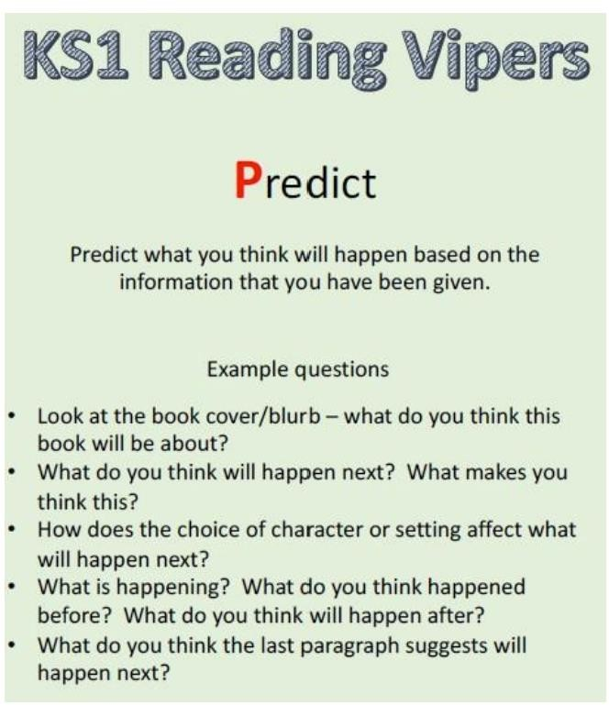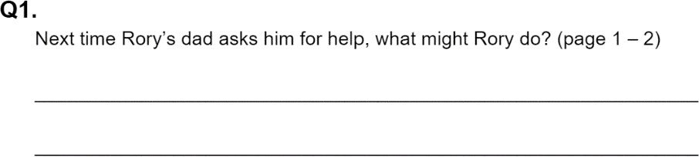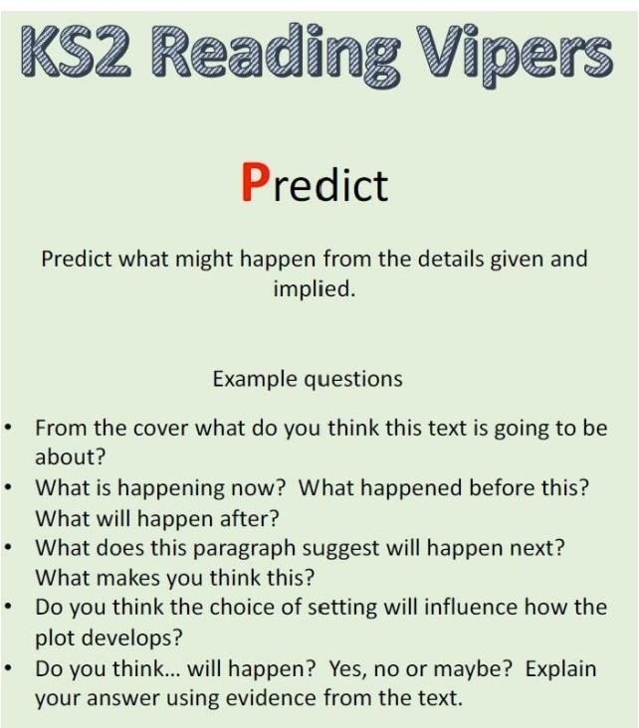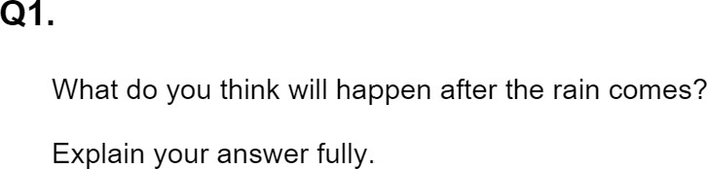

|  |  |  |  |  |
| --- | --- | --- | --- | --- |
| Explain | | | | |
| **Year 2** | **Year 3** | **Year 4** | **Year 5** | **Year 6** |
| Explain what has happened so far in what he/she has read | Checking that the text makes sense to them, discussing their understanding and explaining the meaning of words in context | Checking that the text makes sense to them, discussing their understanding and explaining the meaning of words in context | Maintain positive attitudes to reading and understanding of what he/she reads by making comparisons within a book | Explain and discuss his/her understanding of what he/she has read, including through formal presentations and debates, maintaining a focus on the topic and using notes  where necessary |
|  | identifying how language, structure, and presentation contribute to  meaning |  |  |  |

Example Explain Questions

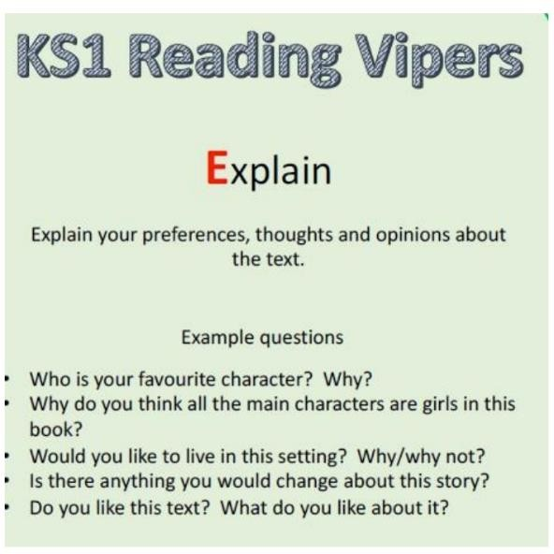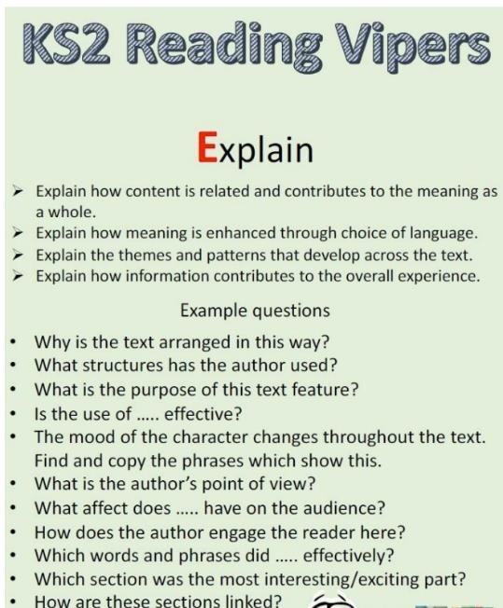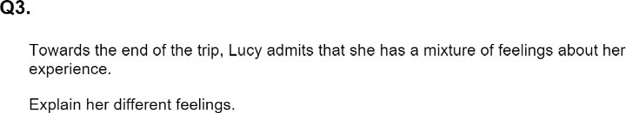

|  |  |  |  |  |
| --- | --- | --- | --- | --- |
| Retrieval | | | | |
| **Year 2** | **Year 3** | **Year 4** | **Year 5** | **Year 6** |
| Answering and asking questions | Understand what he/she reads independently by asking questions to improve his/her understanding of a  text | Retrieve and record information from nonfiction over a wide range of subjects | Understand what he/she reads by asking questions to improve his/her understanding of complex texts | Ask questions to improve their understanding |
|  | Retrieve and record information from nonfiction | Understand what he/she reads independently by asking questions to improve his/her understanding of text with increasing  complexity | Retrieve, record and present information from non-fiction |  |

Example Retrieval Questions

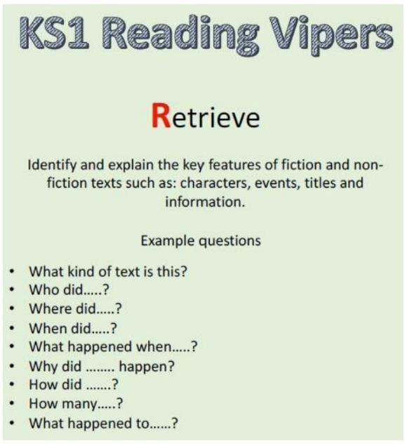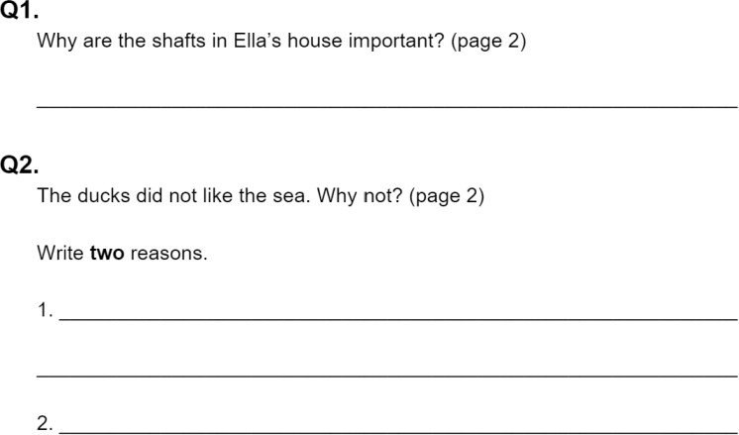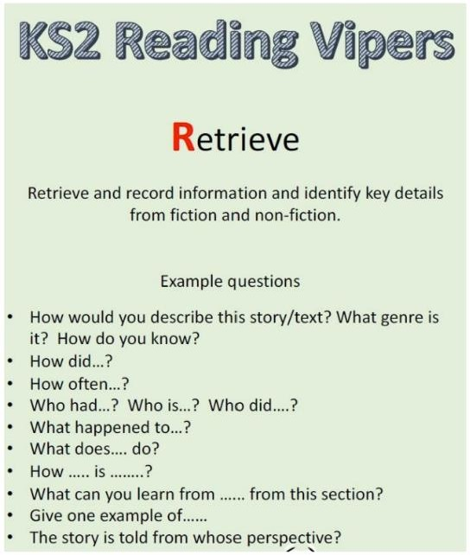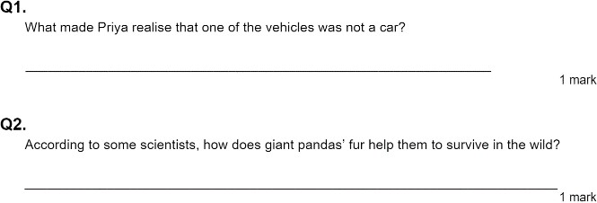

|  |  |  |  |  |
| --- | --- | --- | --- | --- |
| Sequence/Summarise | | | | |
| **Year 2** | **Year 3** | **Year 4** | **Year 5** | **Year 6** |
| Discussing the sequence of events in books and how items of information are related | Understand what he/she reads independently by identifying main ideas drawn from within one paragraph and summarise these | Understand what he/she reads independently by identifying main ideas drawn from more than one paragraph and summarise these | Summarise main ideas from more than one paragraph, identifying key details which support these. | Understand what he/she reads by summarising the main ideas drawn from more than one paragraph, identifying key details that support the main ideas and  using quotation |

Example Sequence/Summarise Quest ions

