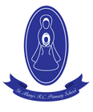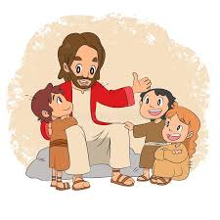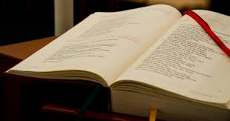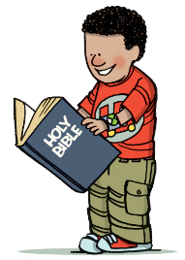

**REFLECTION**

Lord, you fulfilled the hope of Simeon who did not die

until he had been privileged to

welcome the Messiah.

In Sacramental Celebrations we meet the Risen Christ.

May he continue to give us life.

Amen.

The scriptures are the treasured Word of God for the Jewish and Christian communities.

The lectionary which is used at Mass contains the scriptures used by the community throughout the year.

**OUR BIG QUESTION**

Why do we need books?

In the sacred books, the Father who is in heaven comes lovingly to meet his children and talk with them.

**KEY VOCABULARY**

Scripture lectern Gospel Bible New Testament Old Testament genre thurible missal

**BOOKS**

Year 2

**SCRIPTURE**

Matthew 3: 13-17

John 13: 34-35