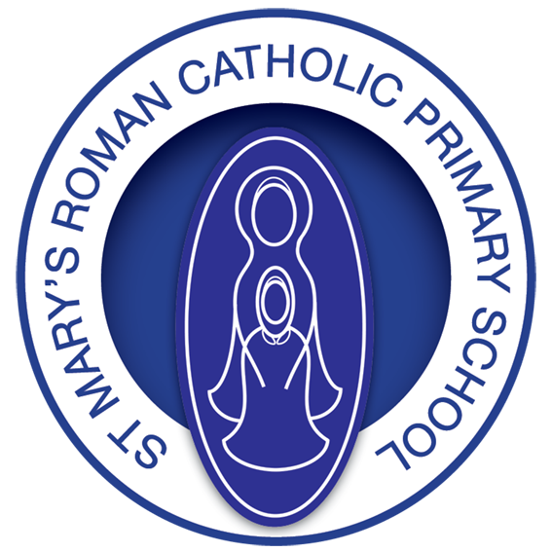

**St Mary’s R.C. Primary**

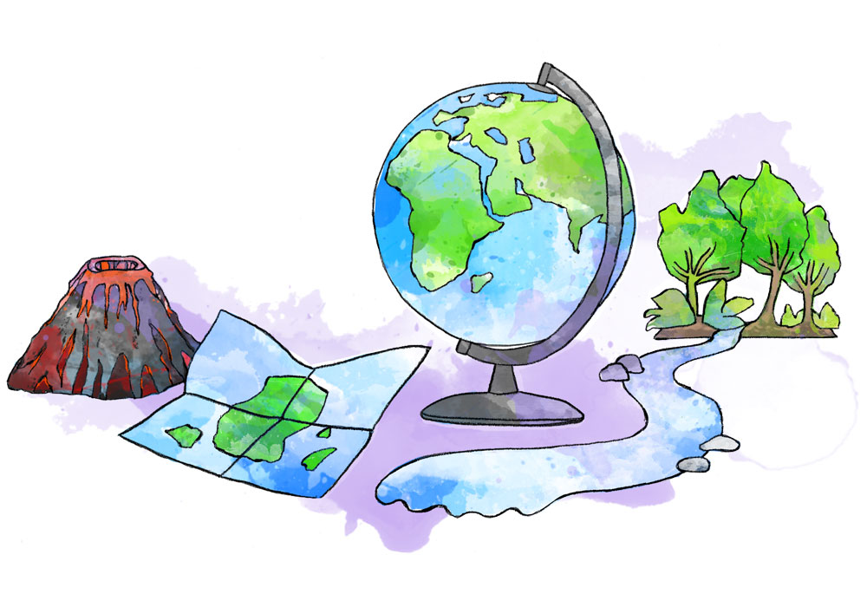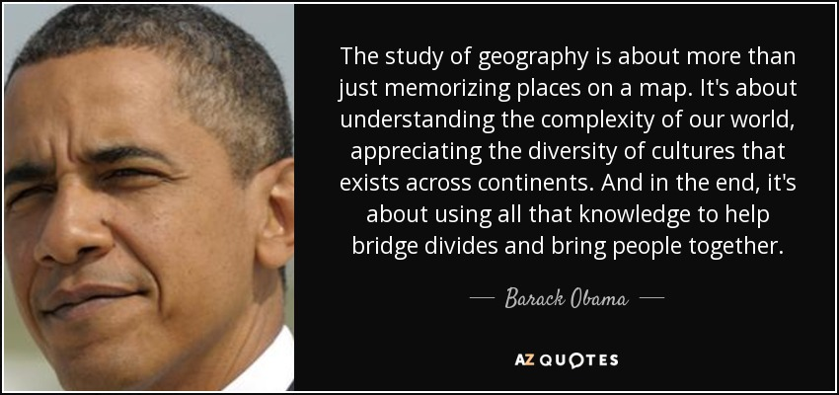

**Geography Annual Curriculum Map**

**St Mary’s R.C. Primary**

**Geography Annual Curriculum Map**

|  |  |  |  |  |  |  |  |  |
| --- | --- | --- | --- | --- | --- | --- | --- | --- |
| **Geography Curriculum Map – Autumn Term** | | | | | | | | |
| **Term** | **Nursery** | **Reception** | **Year 1 and Year 1/2** | **Year 2** | **Year 3** | **Year 4** | **Year 5** | **Year 6** |
| **Autumn 1** | **I wonder who I am?** | **I wonder who I am?** | **What is it like here? (Cycle A)** | **Why is our world wonderful?** | **Why did people live near volcanoes?** | **What are rivers and how are they used?** | **What is life like in the Alps?** | **Why does population change?** |
| **Autumn 2** | **I wonder what we celebrate?** | **I wonder what we celebrate?** |
| **Geography Curriculum Map - Spring Term** | | | | | | | | |
| **Spring 1** | **I wonder what happens as the seasons change?** | **I wonder what happens as the seasons change?** | **What is the weather like in the UK? (Cycle A)** | **Would you prefer to live in a hot/cold place?** | **Blue Wales- Who lives in Antartica?** | **Why are rainforests important to us?** | **Would you like to live in the desert?** | **Where does our energy come from?** |
| **Spring 2** | **I wonder if pirates are real?** | **I wonder if pirates are real?** |
| **Geography Curriculum Map - Summer Term** | | | | | | | | |
| **Summer 1** | **I wonder what lives in the ocean?** | **I wonder what lives in the ocean?** | **What can you see at the coast? (Cycle A)** | **What is it like to live at the coast?** | **Are all settlements the same?** | **Where does food come from?**  **(inc exportation of natural resources)** | **Why do Oceans matter?** | **Can I carry out an independent fieldwork enquiry?** |
| **Summer 2** | **I wonder what happened to the dinosaurs?** | **I wonder what happened to the dinosaurs?** |