**St Mary’s R.C Primary**

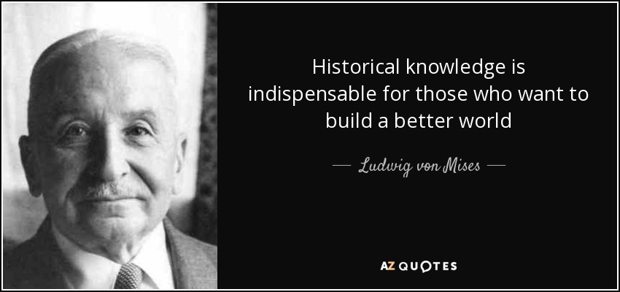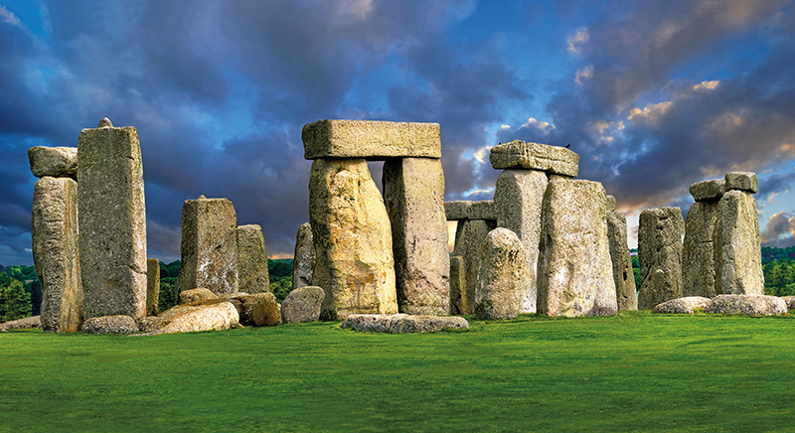

**History Annual Curriculum Map**

**St Mary’s R.C. Primary**

**History Annual Curriculum Map**

|  |  |  |  |  |  |  |  |  |
| --- | --- | --- | --- | --- | --- | --- | --- | --- |
| **History Curriculum Map – Autumn Term** | | | | | | | | |
| **Term** | **Nursery** | **Reception** | **Year 1 and Year 1/2** | **Year 2** | **Year 3** | **Year 4** | **Year 5** | **Year 6** |
| **Autumn 1** | **I wonder who I am?** | **I wonder who I am?** | **How am I making history? (Cycle A)** | **How was school**  **different in the past?** | **Why did the Romans settle in Britain?** | **How have children's lives changed?** | **What did the Greeks ever do for us?** | **What was the impact of World War 2 on the people of Britain?** |
| **Autumn 2** | **I wonder what we celebrate?** | **I wonder what we celebrate?** |
| **History Curriculum Map - Spring Term** | | | | | | | | |
| **Spring 1** | **I wonder what happens as the seasons change?** | **I wonder what happens as the seasons change?** | **How have toys changed? (Cycle A)** | **How did we learn**  **to fly?** | **Would you prefer to have lived in the Stone Age, Bronze Age or Iron Age?** | **How hard was it to**  **invade and settle**  **in Britain?** | **Were the Vikings raiders, traders or something else?** | **What can the census tell us about local areas?** |
| **Spring 2** | **I wonder if pirates are real?** | **I wonder if pirates are real?** |
| **History Curriculum Map - Summer Term** | | | | | | | | |
| **Summer 1** | **I wonder what lives in the ocean?** | **I wonder what lives in the ocean?** | **How did we learn to fly? (Cycle A)** | **What is a Monarch?** | **What did the ancient Egyptians believe?** | **How did the achievements of the Ancient Maya impact their society and beyond?** | **What was life like**  **in Tudor Britain?** | **Unheard histories: Who should feature on the £10 banknote?** |
| **Summer 2** | **I wonder what happened to the dinosaurs?** | **I wonder what happened to the dinosaurs?** |